Source:(1) [Applied Longitudinal Data Analysis: Modeling Change and Event Occurrence](http://www.oxfordscholarship.com/view/10.1093/acprof:oso/9780195152968.001.0001/acprof-9780195152968)

(2) http://www.ats.ucla.edu/stat/r/examples/alda/ch3.htm

or https://stats.idre.ucla.edu/r/examples/alda/r-applied-longitudinal-data-analysis-ch-3/

quote from [Applied Longitudinal Data Analysis: Modeling Change and Event Occurrence](http://www.oxfordscholarship.com/view/10.1093/acprof:oso/9780195152968.001.0001/acprof-9780195152968)

"Each record contains four variables: (1) *ID*; (2) *AGE*, the child’s age (in years) at each assessment (1.0, 1.5, or 2.0);

(3) *COG*, the child’s cognitive performance score at that age; and (4) *PROGRAM*, a dichotomy that describes whether the child participated in the early intervention program."

**Model:**

**Traditional linear regression model (without random effects):**

**What is the disadvantage?**

**Mixed model**

**Measurement error model in Reliability analysis (Random intercept model):**

**e.g. 每人測blood pressure J次**

**Yij: 第i個人第j次測的值**

**eij: measurement error**

**alpha_i:第i個人baseline血壓**

**Traditional Model:**

**Random intercept model (or in general called mixed-effects model):**

**Assumptions:**

**Reliability: the ratio of variance of alpha_i to that of Yij**

**Longitudinal Data Analysis using mixed-effects model**

**Mode12: with random intercepts**

**Model1: with random intercepts and random slopes**

This is an longitudinal study. We would like to find out whether the early intervention has significant effect on

cognition level.; children’s age as an

adjusted variable. (response: cognition value Yij, intervention is the target covariate and age is the adjusted

variable)

**R code:**

**early.int <- read.table("G:/regression/earlyint_pp.txt")**

[Applied Longitudinal Data Analysis, Chapter 3 | R Textbook Examples (ucla.edu)](https://stats.oarc.ucla.edu/r/examples/alda/r-applied-longitudinal-data-analysis-ch-3/)

require(stats)

id<-early.int[,3]

age<-early.int[ , 4]

cog<-early.int[ , 5]

program<-early.int[ ,6]

library(lattice)

time<-age-1

xyplot(cog~age | id, data=early.int,

panel = function(x, y){

panel.xyplot(x, y)

panel.lmline(x, y)

}, ylim=c(50, 150), as.table=T)

require(nlme)

#model1<- lme(cog~time*program, data=early.int, random= ~time | id, method="ML")

#model2<- lme(cog~time*program, data=early.int, random= ~1 | id, method="ML")

#model2<- lme(cog~time*program, data=early.int, random= ~1 | id, method="REML")

model3<- lme(cog~time+program, data=early.int, random= ~1 | id, method="REML")

model4<- lme(cog~time+program, data=early.int, random= ~time | id, method="REML")

Model3 is random intercept model:

Model:

e.g. Matrix form

Model4 is random slope (+random intercept) model:

Model:

e.g. Matrix form

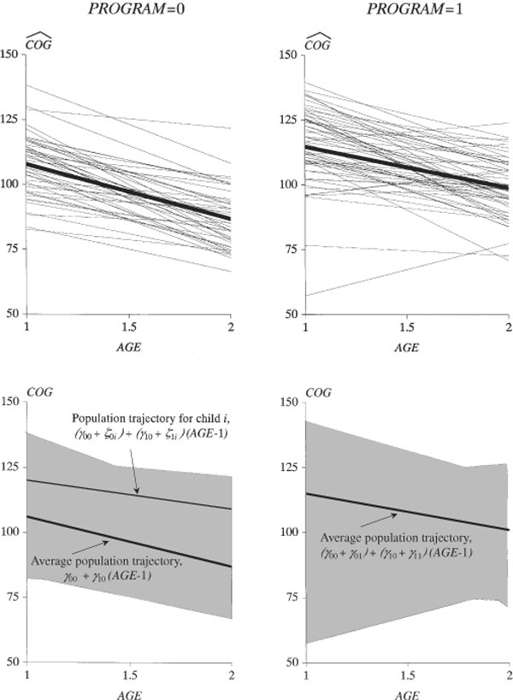

(Figure Courtesy of [Applied Longitudinal Data Analysis: Modeling Change and Event Occurrence](http://www.oxfordscholarship.com/view/10.1093/acprof:oso/9780195152968.001.0001/acprof-9780195152968))

http://www.public.iastate.edu/~dnett/S511/27BLUP.pdf

The general matrix form for the linear mixed-effects model

Matrix form:

e.g.

Assumptions:

How to estimate the fixed effects

Weighted least square estimators

best linear unbiased estimator (Gauss-Markov theorem)

How to estimate the random effects

BLUP: best linear unbiased predictor

The BLUP is the conditional expectation of the random effects given y

Assume that the random effects and errors are normally distributed, the conditional expectation of random effects given y is